PROJECT NAME
(محتاجين نبقى نتفق على اسم)

Name
Rahma Bahgat Muhammad
Bassant Hatem

Table of Contents
- Introduction
- System Purpose
- System Overview
- Functional Requirements
- Non-Functional Requirements
- Use Case Diagram //All
- User Stories
- Use Case Tables / Narratives //R
- Entity Relationship Diagram (ERD) // All
- Sequence Diagrams //M
- Activity Diagrams //M

1. Introduction
The rapid growth of the tourism industry and the increasing reliance on digital platforms have transformed how travelers plan and book their trips. Traditional travel agencies often face challenges in managing offers, reaching customers, and providing flexible payment options, while travelers struggle to find suitable trips that match their budgets and preferences.
This project introduces a Travel Agency System that provides a centralized digital platform connecting travelers with multiple travel agencies. The system aims to simplify travel planning, improve accessibility to travel services, and enhance the overall user experience through smart budget-based recommendations and installment-based booking options.

2. System Purpose
The purpose of the Travel Agency System is to provide an integrated and user-friendly platform that enables travelers to discover, plan, and book travel experiences efficiently. The system allows users to explore various travel services such as hotels, tourist destinations, events, safaris, yacht rentals, and complete travel packages offered by registered travel agencies.
The system also aims to make travel more affordable by supporting installment-based payment plans and trip savings features. For travel agencies, the system serves as a digital marketplace to promote their services, manage travel packages, define installment plans, and interact with customers. Additionally, the system supports administrators in managing users, approving agencies, and maintaining secure and reliable system operations.

2.1 Objectives
- Enable users to plan trips efficiently with personalized recommendations
- Provide flexible installment-based booking for affordability
- Allow users to save and track funds for future trips
- Facilitate travel agencies in managing offerings and installment plans
- Ensure administrators maintain system integrity and security

2.2 Benefits to Users and Stakeholders
- Travelers: Easier trip planning, cost-effective booking, and financial goal tracking
- Travel Agencies: Improved service visibility and management of bookings
- Administrators: Efficient oversight, security, and system monitoring

2.3 Key Features Overview
- Travel search with filters for budget, location, and preferences
- Booking trips with installment payments
- Notifications for offers, discounts, and due payments
- Trip savings goal management
- Dashboard for agencies and system administration

3. System Overview
The Travel Agency System is a web-based application developed using Full Stack .NET technologies. It follows a layered architecture that separates the presentation layer, business logic layer, and data access layer to ensure scalability, maintainability, and security.
The system supports multiple user roles, including travelers, travel agencies, and administrators. Travelers can create accounts, set travel budgets, receive personalized recommendations, save money for future trips, and book travel packages using flexible installment plans. Travel agencies can register on the platform, add and manage travel packages, define installment options, and track customer bookings. Administrators oversee system operations, manage users and agencies, and monitor overall system performance.
The platform integrates with external payment services to handle installment payments securely and includes a notification system to inform users about payment schedules, special offers, and suitable travel opportunities based on their budget.

Requirements Priority Table
Priority | Description
1 | Critical functionality that is essential for the core purpose of the system.
2 | Important features that enhance the user experience but may not be critical for basic functionality.
3 | Additional features that contribute to the overall system but can be implemented after critical and important features.

Functional Requirements

1. Sign Up (Priority 1)
- The system will have three types of users: Traveler, Travel Agency, and Administrator. Users can select their type during signup.
1.1 Traveler:
- Users can create accounts by providing basic personal information: Full Name, Email, Password, Age, and Phone Number.
- After signup, travelers can browse travel options, book trips, and track savings.
1.2 Travel Agency:
- Agencies submit a request to join the system, including: Full Name, Email, Contact Details, Address, and required documents (e.g., Business License, ID).
- Once approved, agencies can create and manage travel packages, installment plans, and receive booking orders.
1.3 Administrator:
- Admin accounts are created manually or through system registration. Admins oversee system operations, approve agencies, and ensure security and reliability.

2. Sign In (Priority 1)
- All users must sign in using email and password.
- System authenticates users by validating credentials against the database.
- Access permissions differ based on user type.

3. Search & Browse Travel (Priority 1)
- Travelers can search for trips, packages, hotels, events, and safaris using filters such as budget, location, and travel dates.
- Travelers can view detailed information for each travel option: Name, Description, Price, Reviews, and Availability.
- Recommendations are personalized based on user preferences, travel history, and budget.

4. Travel Package Management (Priority 1)
- Travel agencies can create and update packages including:
  - Package name, description, itinerary, images, price
  - Availability dates, locations, and capacity
- Agencies can modify packages, update prices, and remove unavailable options.

5. Booking & Installment Payment (Priority 1)
- Travelers can book packages with flexible installment options, including down payments and monthly schedules.
- Users can register or update payment details securely.
- System tracks installment payments and sends reminders for due dates.

6. Trip Savings & Financial Goals (Priority 2)
- Travelers can set financial goals for future trips.
- System tracks savings contributions and progress toward the goal.
- Notifications alert users when goals are met or when special offers match their target.

7. Order Tracking & Notifications (Priority 2)
- Real-time notifications for booking confirmation, upcoming payments, and travel updates.
- Travelers can track their trip status, including transportation or package confirmations.
- Agencies and admins receive notifications of booking activities and requests.

8. Customer Support Service (Priority 2)
- Multi-channel support: In-app messaging, email, and phone.
- Assistance available for booking issues, payment disputes, and travel inquiries.

10. Integration with Google Maps (Priority 3)
- Map integration for:
  - Travelers: Locate hotels, events, and attractions.
  - Agencies: Define locations of services and packages.
  - Travel tracking and directions.

11. Cancellation (Priority 1)
- Travelers can cancel bookings within a specified time frame before trip start.
- System updates availability and notifies agencies.

12. Rating & Review (Priority 3)
- Travelers can rate packages, trips, and agencies (1–5 stars).
- Written feedback and photos can be submitted.
- Ratings influence recommendations and provider credibility.

14. Email Verification (Priority 1)
- System sends verification emails with unique tokens.
- Verification links expire after 24 hours.
- Users can resend verification emails or update email addresses.

15. Enhanced Travel Management (Priority 2)
- Route optimization for travel packages and transfers.
- Integration with live traffic and travel data.
- Real-time communication between travelers and agencies.
- Efficient interface for managing trips, itineraries, and bookings.

16. Hotel Management (Priority 2)
- Travel agencies can register and manage hotels.
- Hotel Details: Name, Location, Price per night, Amenities, Images.
- Agencies can add, edit, or remove hotels.
- Hotels are linked to the registering agency.
- Travelers can view hotel availability and details before booking.
- Booking supports full payment or installment-based payment.
- System sends booking confirmations and reminders to both traveler and agency.

17. Event Management (Priority 2)
- Travel agencies can add and manage events.
- Event Details: Name, Location, Date, Ticket Price, Description.
- Agencies can update or cancel events.
- Events are linked to the organizing agency.
- Travelers can view event details and book tickets.
- Booking supports full payment or installment-based payment.
- System tracks attendance and sends confirmations to both traveler and agency.

18. Yacht Management (Priority 2) //active
- Travel agencies can register and manage yacht rentals.
- Yacht Details: Name, Type, Capacity, Rental Price, Amenities, Images, Availability Dates.
- Agencies can add, edit, or remove yachts.
- Yachts are linked to the registering agency.
- Travelers can view yacht availability, details, and book rentals.
- Booking supports full payment or installment-based payment.
- System sends confirmations and reminders to both traveler and agency.

Non-Functional Requirements

1. Security (Priority 1)
- Encrypt user data in transit and at rest using AES.
- Multi-factor authentication for account access.
- Passwords hashed with Scrypt algorithm and salted.
- Payment processing via secure gateways with SSL/TLS encryption and tokenization.
- Regular security audits and compliance with industry standards.
1.1 Payment Security:
- Secure integration with payment gateways (PayPal, Stripe, etc.)
- Encrypted transmission of sensitive data
- Authorization handling with banks via SSL
- Transaction logging and monitoring for fraud detection

2. Reliability (Priority 1)
- Redundant servers and backup systems to maintain availability.
- Automated monitoring tools (APM) to detect failures.
- Transaction rollback for database integrity.
- Load testing and optimization for high performance.

3. Scalability (Priority 2)
- System designed to handle 2000+ users concurrently.
- Horizontal and vertical scaling with load balancers.
- Continuous monitoring and analytics for performance and capacity planning.

4. Performance (Priority 2)
- Smooth and responsive interface.
- Expected response times:
  - Listings/menus: < 100ms
  - Detailed info/images: < 500ms
  - Booking/payment confirmation: < 2s
  - Real-time notifications: 1–2s
  - User mode switch: < 500ms

5. Availability (Priority 1)
- Maintain 99.9% uptime, including redundancy and failover mechanisms.
- Monitoring, alerting, and disaster recovery plans in place.
- Regular backups stored securely in off-site locations (e.g., cloud storage).

User Stories / Scenarios

1. User Sign Up
Story:
“As a traveler or a travel agency, I want to sign up so that I can have an account on the platform.”
Acceptance Criteria:
- Sign-up page must include: Full Name, Email, Phone Number, Password, and option to select Traveler or Travel Agency.
- Email and phone number must be verified via confirmation code.
- For Travel Agencies, required documents (Business License, ID) must be uploaded and verified by admin.
- Password must be at least 8 characters.
- Password must include at least one lowercase letter, one uppercase letter, one number, and one special character (!,@,#,$,%,^,&,*).

2. User Sign In
Story:
“As a registered user, I want to log in so that I can access my account and its features.”
Acceptance Criteria:
- Users must enter valid email and password.
- System verifies credentials before granting access.
- Access permissions depend on user role (Traveler / Travel Agency / Admin).
- Invalid login attempts must show an error message.

3. Search and Browse Travel Options
Story:
“As a traveler, I want to search and browse travel packages, hotels, and events so that I can find suitable options.”
Acceptance Criteria:
- Users can filter by location, budget, travel dates, or trip type.
- Packages show details: Name, Description, Price, Dates, Reviews, Images.
- Recommendations are based on traveler preferences and past bookings.

4. Booking & Installment Payment
Story:
“As a traveler, I want to book trips and pay in installments so that I can manage my budget.”
Acceptance Criteria:
- Travelers can choose full payment or installment plan.
- System tracks payments and sends reminders for due dates.
- Booking confirmation is sent to user and agency.
- Payment process is secure.

5. Travel Package Management
Story:
“As a travel agency, I want to manage my travel packages so that travelers can view and book them.”
Acceptance Criteria:
- Agencies can add, edit, or remove packages.
- Each package includes Name, Description, Price, Itinerary, Images, and Availability Dates.
- Changes are reflected immediately for travelers browsing packages.

6. Ratings & Reviews
Story:
“As a traveler, I want to rate and review trips and agencies so that I can provide feedback and help other travelers.”
Acceptance Criteria:
- Travelers can rate trips and agencies on a scale of 1–5.
- Users can write comments and upload photos.
- Ratings and reviews are visible to other travelers.

1. Hotel Management
Story:
“As a travel agency, I want to register and manage my hotels so that travelers can find and book them easily.”
Acceptance Criteria:
- Agencies can add hotels with Name, Location, Price per night, Amenities, and Images.
- Agencies can edit hotel details or remove hotels from the system.
- Hotels are linked to the agency that registers them.
- Travelers can see hotel availability and details before booking.

2. Event Management
Story:
“As a travel agency, I want to add and manage events so that travelers can attend and book them.”
Acceptance Criteria:
- Agencies can add events with Name, Location, Date, Ticket Price, and Description.
- Agencies can update event information or cancel events.
- Events are linked to the agency that organizes them.
- Travelers can view event details and book tickets.

3. Hotel Booking
Story:
“As a traveler, I want to book hotels so that I can reserve my stay during my trip.”
Acceptance Criteria:
- Travelers can select a hotel and view details before booking.
- Travelers can make full payment or installment payment.
- Booking confirmation is sent to both the traveler and agency.
- System tracks booking status and sends reminders.

4. Event Booking
Story:
“As a traveler, I want to book events so that I can attend them during my trip.”
Acceptance Criteria:
- Travelers can select an event and see details before booking.
- Travelers can pay for tickets fully or in installments.
- Booking confirmation is sent to both traveler and agency.
- System tracks attendance and payment status.

5. Integrated Trip Booking
Story:
“As a traveler, I want to book travel packages, hotels, and events together so that I can plan my full trip efficiently.”
Acceptance Criteria:
- Travelers can combine packages, hotels, and events in one booking.
- System calculates total cost and installment schedule.
- Booking confirmation is sent to traveler and all involved agencies.
- Users receive notifications for due payments and updates.

6. Hotel Management
- Story: “As a travel agency, I want to register and manage my hotels so that travelers can find and book them easily.”
- Acceptance Criteria:
  - Agencies can add hotels with Name, Location, Price per night, Amenities, and Images.
  - Edit or remove hotel details.
  - Hotels linked to agency.
  - Travelers can see hotel availability and details.
  - Booking confirmation sent to both traveler and agency.

7. Event Management
- Story: “As a travel agency, I want to add and manage events so that travelers can attend and book them.”
- Acceptance Criteria:
  - Agencies can add events with Name, Location, Date, Ticket Price, and Description.
  - Update or cancel events.
  - Events linked to agency.
  - Travelers can view event details and book tickets.
  - Booking confirmation sent to traveler and agency.

8. Yacht Management
- Story: “As a travel agency, I want to manage yacht rentals so that travelers can book them easily.”
- Acceptance Criteria:
  - Agencies can add yachts with Name, Type, Capacity, Rental Price, Amenities, Images, and Availability Dates.
  - Edit or remove yacht details.
  - Yachts linked to agency.
  - Travelers can view yacht availability and details.
  - Booking confirmation sent to traveler and agency.
  - System tracks payment status and sends reminders.

7. Email Verification
Story:
“As a user, I want my email verified so that my account is secure and valid.”
Acceptance Criteria:
- System sends a verification email after signup.
- Verification link expires after 24 hours.
- Users can request a new verification email if needed.

Use Case Narratives:
Use Case 1: Sign Up
Use Case Name | Sign Up
Actor | Traveler, Travel Agency, Administrator
Description | This use case describes how a new user (Traveler, Travel Agency, or Administrator) registers an account in the Travel Agency System.
Preconditions | - The user does not already have an account.  - The system is online and available.
Postcondition | - A new user account is created.  - Traveler accounts are activated immediately.  - Travel Agency accounts remain pending until admin approval.  - Administrator accounts are created with full system access.
Flow Of Events | - The user selects Sign Up from the system interface.  - The system asks the user to choose an account type (Traveler, Travel Agency, or Administrator).  - The user enters the required registration information.  - The system validates the entered data.  - The system saves the user information in the database.  - The system confirms successful registration.
Alternative Events | A1: Traveler Registration  - The traveler enters Full Name, Email, Password, Age, and Phone Number.  - The system validates the information.  - The system creates a traveler account.  - The traveler gains access to browse trips, book travel packages, and track savings.  A2: Travel Agency Registration  - The agency submits Full Name, Email, Contact Details, Address, and required documents.  - The system stores the request with status Pending.  - The system notifies the administrator.  - The administrator reviews and approves the agency.  - The system activates the agency account.  A3: Administrator Registration  - The administrator account is created manually or through system registration.  - The system grants full administrative privileges.

Use Case 2: Sign In
Use Case Name | Sign In
Actor | Traveler, Travel Agency, Administrator
Description | This use case describes how a registered user logs into the system using valid credentials.
Preconditions | - The user has a registered account.  - The account is active (agency account must be approved).
Postconditions | - The user is authenticated.  - The system grants access based on user role.
Flow Of Events | - The user selects Sign In from the system interface.  - The user enters Email and Password.  - The system validates the credentials against the database.  - The system identifies the user role.  - The system redirects the user to the appropriate dashboard.
Alternative Events | A1: Invalid Credentials  - The system detects incorrect email or password.  - The system displays an error message.  - The user is prompted to retry.  A2: Unapproved Agency Account  - The system detects that the agency account is still pending approval.  - The system displays a notification indicating approval is required.  - Access is denied until approval.

Use Case 3: Search & Browse Travel
Use Case Name | Search & Browse Travel
Actor | Traveler
Description | This use case describes how a traveler searches and browses available travel options such as trips, packages, hotels, events, and safaris.
Preconditions | - The traveler is signed in to the system.
Postconditions | - Matching travel options are displayed.  - Personalized recommendations are generated for the traveler.
Flow Of Events | - The traveler selects the search option.  - The traveler enters search filters such as budget, location, and travel dates.  - The system retrieves matching travel options.  - The system displays a list of available results.  - The traveler selects a travel option.  - The system displays detailed information including name, description, price, reviews, and availability.  - The system provides personalized recommendations based on preferences, travel history, and budget.
Alternative Events | If no matching results are found, the system displays a message indicating no available options.

Use Case 4: Travel Package Management
Use Case Name | Travel Package Management
Actor | Travel Agency
Description | This use case describes how a travel agency creates, updates, and manages travel packages offered to travelers.
Preconditions | - This use case describes how a travel agency creates, updates, and manages travel packages offered to travelers.
Postconditions | - Travel packages are added, updated, or removed successfully.
Flow Of Events | - The travel agency accesses the package management dashboard.  - The agency creates a new travel package by entering package details.  - The system saves the package information.  - The agency updates package details such as price, availability, or capacity.  - The system applies the updates.  - The agency removes unavailable packages when needed.
Alternative Events | If required package information is missing, the system requests the agency to complete the data.

Use Case 5: Booking & Installment Payment
Use Case Name | Booking & Installment Payment
Actor | Traveler
Description | This use case describes how a traveler books a travel package and completes payment using an installment-based plan.
Preconditions | - The traveler is signed in.  - The selected travel package is available.
Postconditions | - A booking is created successfully.  - Installment payment schedule is generated.  - Payment reminders are scheduled.
Flow Of Events | - The traveler selects a travel package.  - The traveler chooses a booking option.  - The traveler selects an installment payment plan.  - The traveler enters or updates payment details.  - The system confirms the booking.  - The system generates an installment schedule.  - The system tracks payments and schedules reminders for due dates.
Alternative Events | If payment information is invalid, the system requests corrected details.

Use Case 6: Cancellation
Use Case Name | Cancellation
Actor | Traveler
Description | This use case describes how a traveler cancels a previously booked trip within the allowed cancellation period.
Preconditions | - The traveler is signed in.  - The booking exists and is within the allowed cancellation time frame.
Postconditions | - The booking status is updated to cancelled.  - Package availability is updated.  - The travel agency is notified.
Flow Of Events | - The traveler accesses their booking history.  - The traveler selects a booking to cancel.  - The traveler confirms the cancellation request.  - The system validates the cancellation time frame.  - The system updates the booking status.  - The system updates package availability.  - The system notifies the travel agency of the cancellation.
Alternative Events | If the cancellation period has expired, the system prevents cancellation and displays a message.

Use Case 7: Email Verification
Use Case Name | Email Verification
Actor | User
Description | This use case describes how a user verifies their email address after registration.
Preconditions | - The user has completed the sign-up process.  - The user has not yet verified their email.
Postconditions | - The user’s email address is verified.  - The user gains full access to system features.
Flow Of Events | - The system sends a verification email containing a unique token.  - The user opens the verification email.  - The user clicks the verification link.  - The system validates the token and its expiration time.  - The system marks the email as verified.
Alternative Events | - The user requests to resend the verification email.  - The user updates their email address and receives a new verification link.

Use Case 8: Trip Savings & Financial Goals
Use Case Name | Trip Savings & Financial Goals
Actor | Traveler
Description | This use case describes how a traveler creates and manages savings goals for future trips.
Preconditions | - The traveler is signed in.
Postconditions | - A savings goal is created or updated.  - Savings progress is tracked.  - Notifications are generated when goals are achieved or matched with offers.
Flow Of Events | - The traveler creates a new savings goal.  - The traveler sets a target amount and target date.  - The system saves the savings goal.  - The traveler adds savings contributions.  - The system updates the savings progress.  - The system monitors the goal status.  - The system notifies the traveler when the goal is reached or relevant offers are available.
Alternative Events | - The traveler edits or deletes an existing savings goal.

Use Case 9: Trip Savings & Financial Goals
Use Case Name | Order Tracking & Notifications
Actor | Traveler, Travel Agency, Administrator
Description | This use case describes how users receive notifications related to bookings, payments, and travel updates, and how travelers track the status of their trips.
Preconditions | - The user is signed in.  - A booking or travel order exists in the system.
Postconditions | - Notifications are delivered to users.  - Travelers can view up-to-date trip status information.
Flow Of Events | - The system detects a booking activity, payment update, or travel change.  - The system sends a notification to the relevant users.  - The traveler accesses the order tracking section.  - The system displays the current trip status and confirmations.  - Travel agencies and administrators view notifications related to booking activities and requests.
Alternative Events | - If there are no updates, the system displays the latest available status.

Use Case 10: Customer Support Service
Use Case Name | Customer Support Service
Actor | Traveler, Travel Agency
Description | This use case describes how users request and receive support for issues related to bookings, payments, and travel inquiries.
Preconditions | - The user is signed in.
Postconditions | - A support request is submitted.  - The user receives assistance or guidance.
Flow Of Events | - The user accesses the customer support section.  - The user selects a support channel (in-app messaging, email, or phone).  - The user submits a support request.  - The system records the request.  - The user receives assistance regarding the issue.
Alternative Events | - If the selected support channel is unavailable, the system suggests another available option.

Use Case 11: Enhanced Travel Management
Use Case Name | Enhanced Travel Management
Actor | Traveler, Travel Agency
Description | This use case describes advanced travel management features that improve trip efficiency and communication.
Preconditions | - The user is signed in.  - A valid trip or booking exists.
Postconditions | - Travel routes and itineraries are optimized.  - Real-time communication between travelers and agencies is enabled.  - Trip management information is updated.
Flow Of Events | - The user accesses the travel management interface.  - The system optimizes travel routes and transfers.  - The system integrates live traffic and travel data.  - The system updates itineraries and trip details.  - The traveler and travel agency communicate in real time.  - The system saves all updates.
Alternative Events | - If live travel data is unavailable, the system uses the most recent available data.

Sequence Diagrams:
1. User Registration & Email Verification
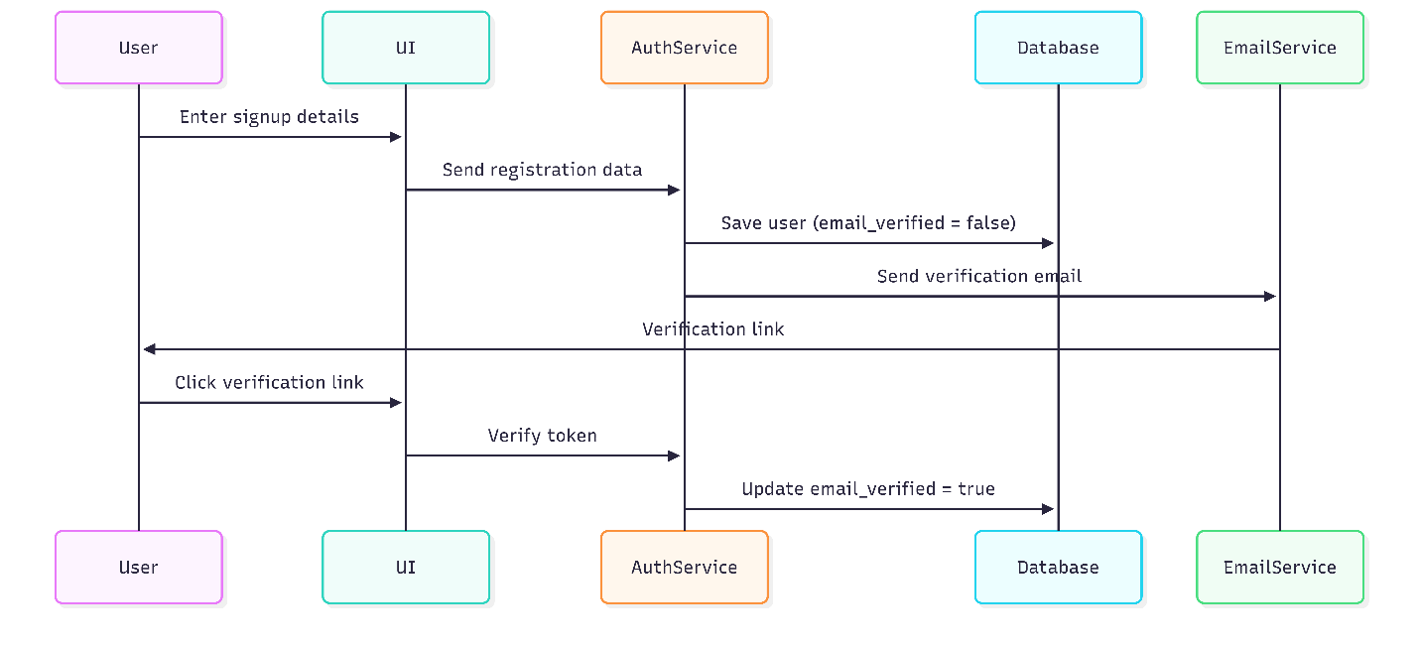
2. Travel Agency Registration & Approval
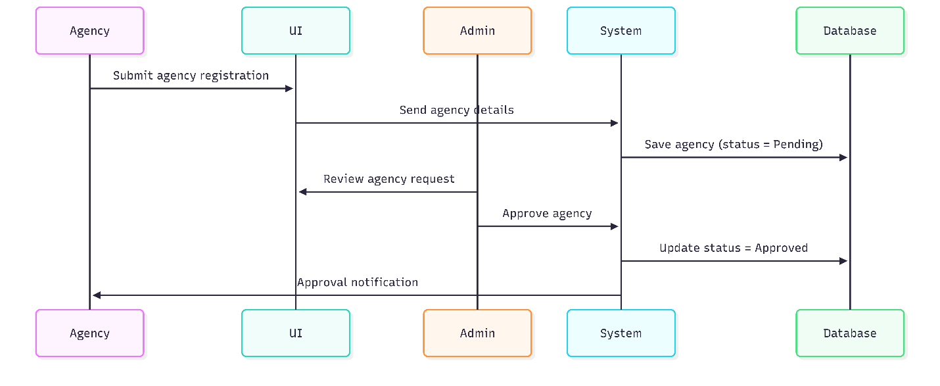

3. Search & Browse Travel Packages
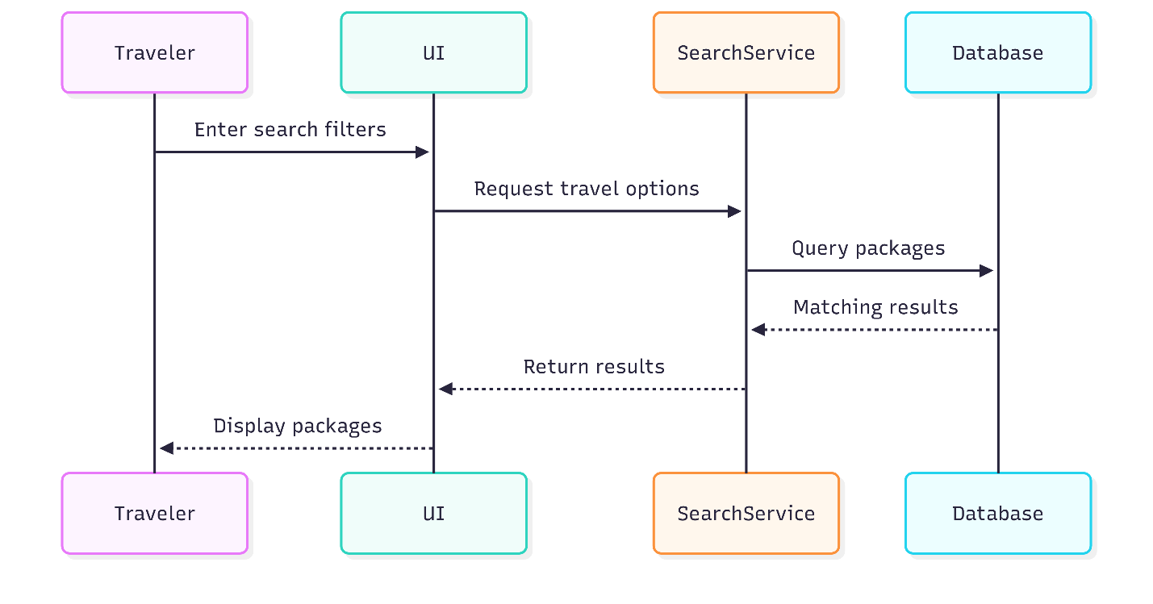

- Booking with Installment Payment
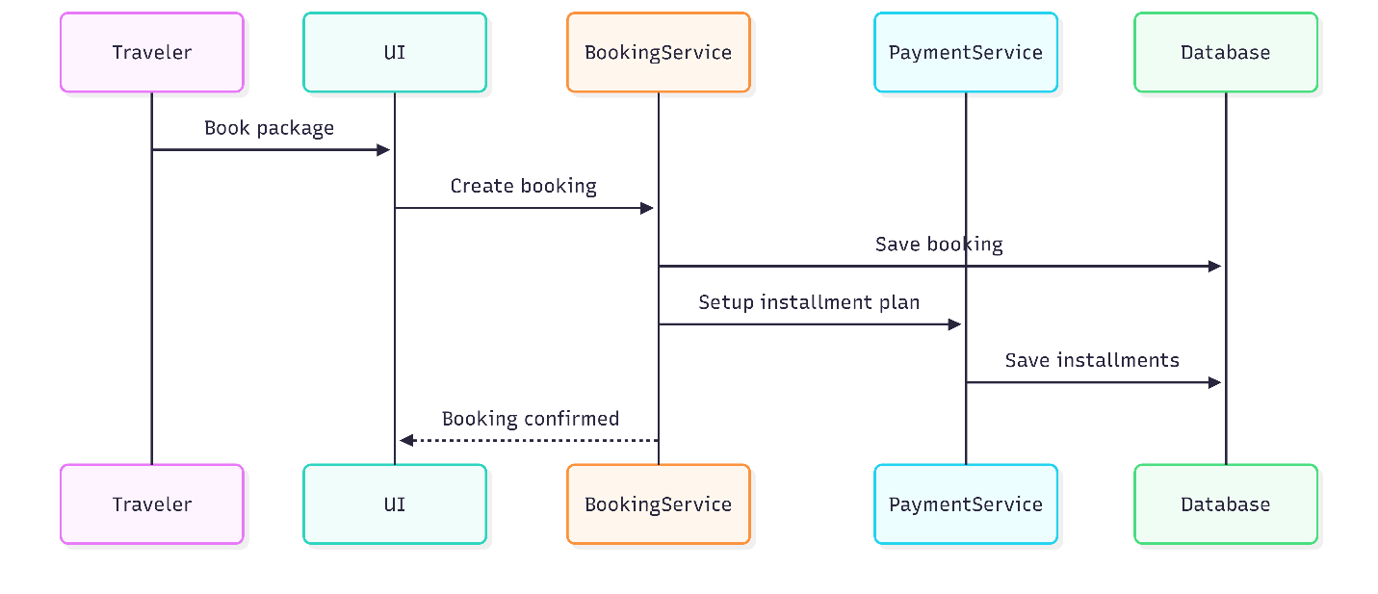

5. Installment Payment & Reminder
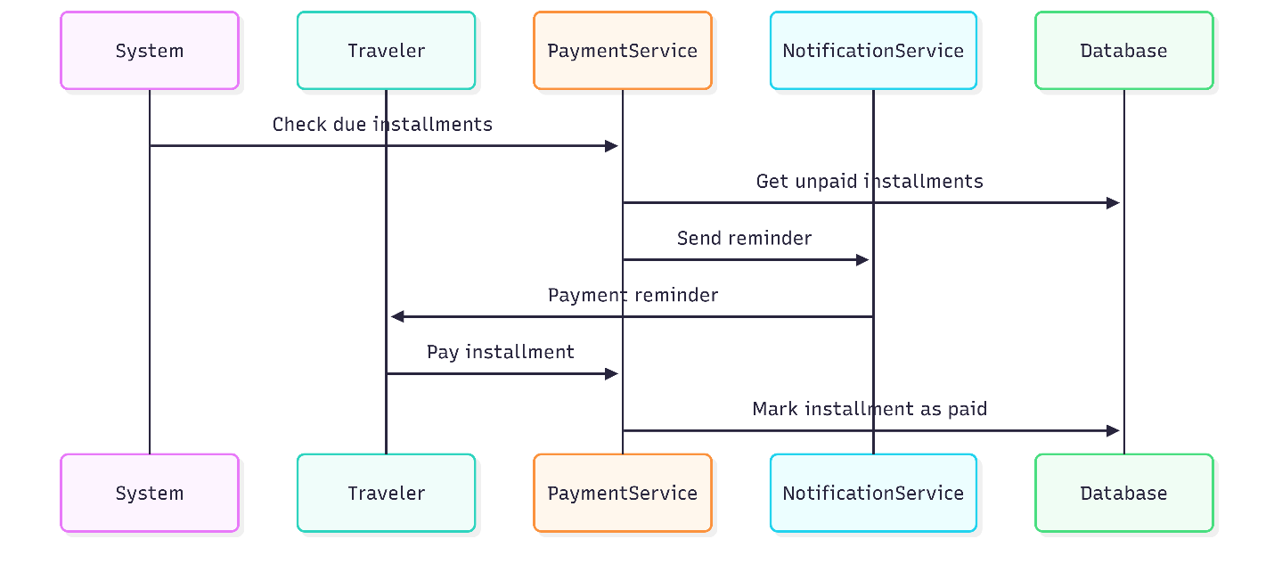

6. Trip Savings Goal Management
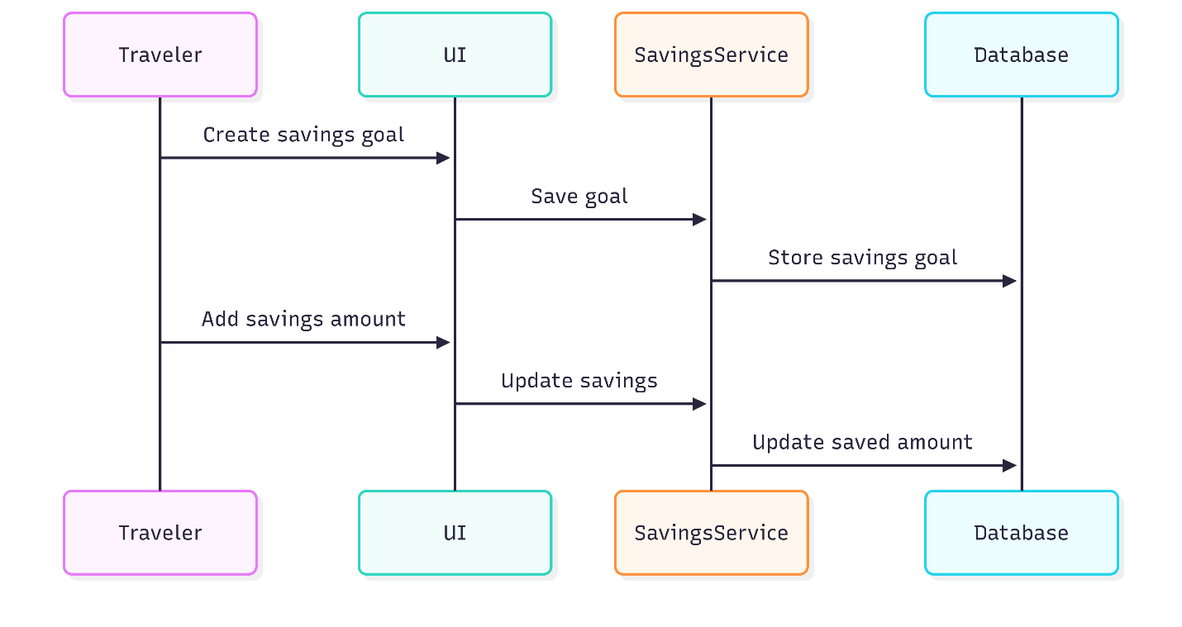

7. Hotel / Event / Yacht Management
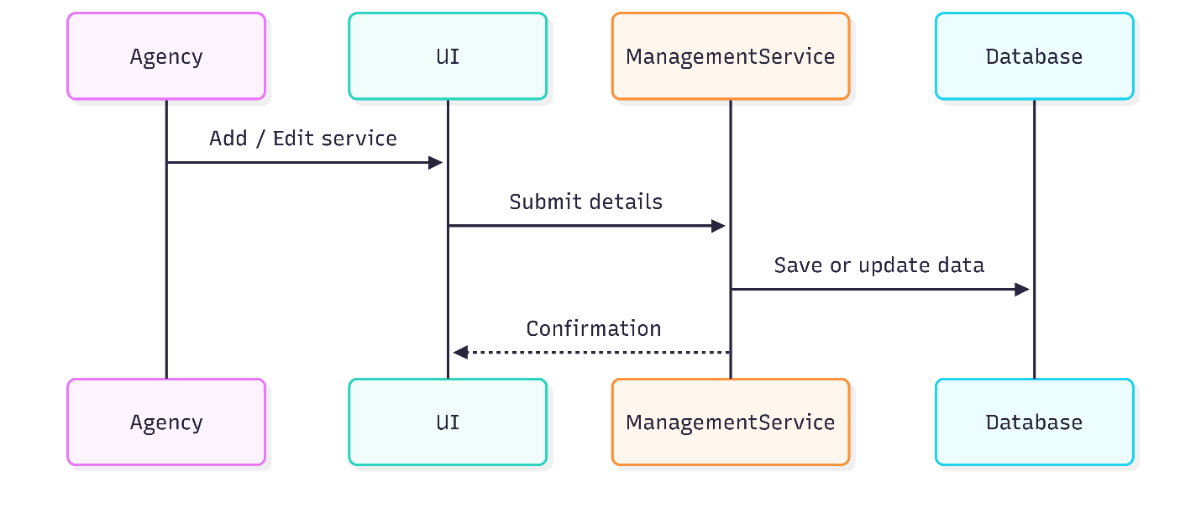

8. Rating & Review Submission
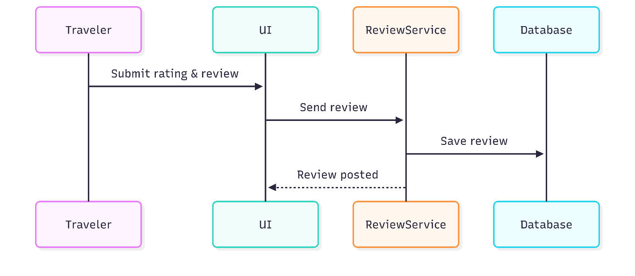

9. Booking Cancellation
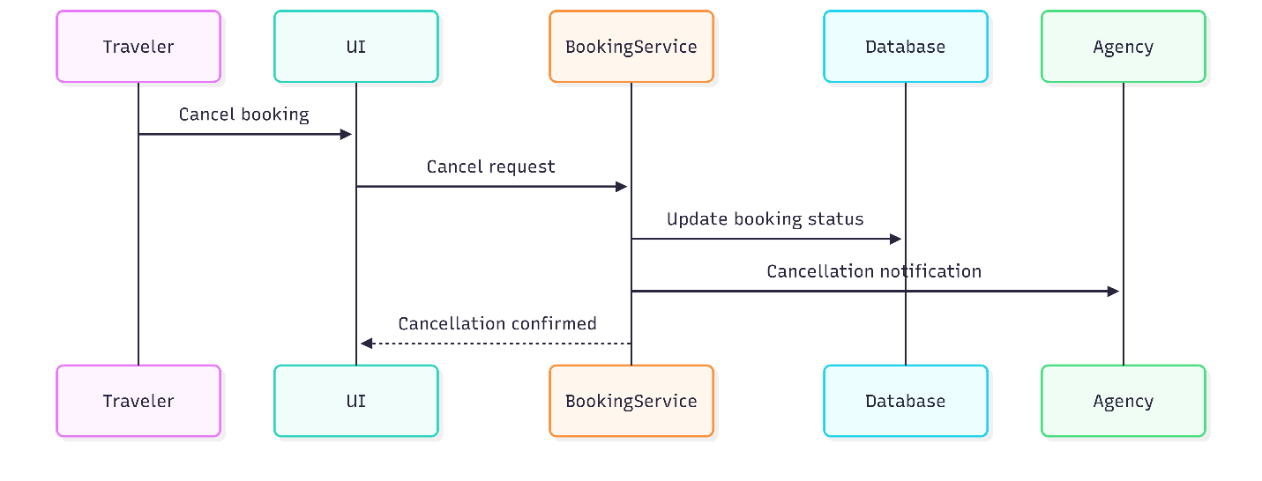

ERD

